Task 1: Drawing Pixels

You are supposed to draw 50 pixels (coordinate points). For this you need to generate
100 random values (300 x - coordinates and 300y - coordinates). You do not need to join
any pixels for this task.

Task2: Write your Name initial & ID

You are asked to draw the last 4 digits of your Name initial and last 4 digits of your student ID
You can use GL_POINTS and GL_LINES for this task.

Example; ALE
1011

Task 3: House Building

You are to draw a House using the base primitives: points, lines, or triangles. You can
use GL_POINTS, GL_LINES or GL_TRIANGLES for designing this house. A diagram
has been provided as an example. You can modify the house design to your liking.

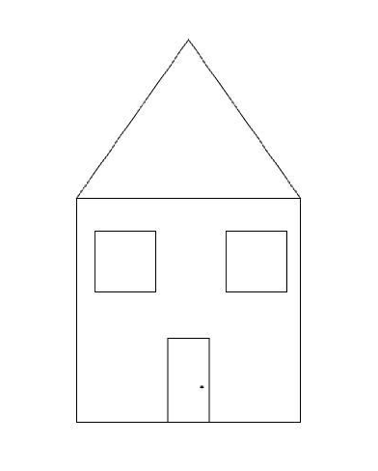

SUBMISSION LINK

